TASK 18

AIM
To design and implement unit test cases for a Java-based microservice using a standard testing framework. The objective is to independently validate:
- Service-layer business logic
- REST controller endpoints
- Data access layer (repository interactions)
This ensures correctness, isolation, and reliability of each microservice component.

ALGORITHM
Step 1: Project Setup
- Create a Maven-based Spring Boot project.
- Add dependencies:
  - Spring Web
  - Spring Data JPA
  - H2 Database (for testing)
  - JUnit 5
  - Mockito
Step 2: Define Microservice Components
- Create an Entity class (e.g., User)
- Create a Repository interface extending JpaRepository
- Create a Service class containing business logic
- Create a REST Controller exposing endpoints
Step 3: Write Unit Tests for Service Layer
- Mock repository using Mockito
- Inject mocks into service
- Test:
  - Valid data flow
  - Edge cases
  - Exception scenarios
Step 4: Write Unit Tests for Controller
- Use @WebMvcTest
- Mock service layer
- Use MockMvc to simulate HTTP requests
- Validate:
  - Response status
  - JSON structure
  - Returned data
Step 5: Test Data Handling
- Use in-memory DB (H2) or mocked repository
- Verify CRUD operations
- Validate persistence behavior
Step 6: Execute Tests
- Run using Maven:
- Verify all test cases pass successfully

CODE

1. Entity Class
Java
@Entity
public class User {
@Id
@GeneratedValue(strategy = GenerationType.IDENTITY)
private Long id;
private String name;
}

2. Repository
Java
public interface UserRepository extends JpaRepository<User, Long> {
}

3. Service Class
Java
@Service
public class UserService {
@Autowired
private UserRepository repo;
public User saveUser(User user) {
return repo.save(user);
}
public List<User> getAllUsers() {
return repo.findAll();
}
}

4. Controller
Java
@RestController
@RequestMapping("/users")
public class UserController {
@Autowired
private UserService service;
@PostMapping
public User addUser(@RequestBody User user) {
return service.saveUser(user);
}
@GetMapping
public List<User> getUsers() {
return service.getAllUsers();
}
}

UNIT TEST CASES
5. Service Layer Test
Java
@ExtendWith(MockitoExtension.class)
public class UserServiceTest {
@Mock
private UserRepository repo;
@InjectMocks
private UserService service;
@Test
void testSaveUser() {
User user = new User();
user.setName("John");
Mockito.when(repo.save(user)).thenReturn(user);
User saved = service.saveUser(user);
assertEquals("John", saved.getName());
}
}

6. Controller Test
Java
@WebMvcTest(UserController.class)
public class UserControllerTest {
@Autowired
private MockMvc mockMvc;
@MockBean
private UserService service;
@Test
void testGetUsers() throws Exception {
List<User> users = List.of(new User());
Mockito.when(service.getAllUsers()).thenReturn(users);
mockMvc.perform(get("/users"))
.andExpect(status().isOk());
}
}

OUTPUT

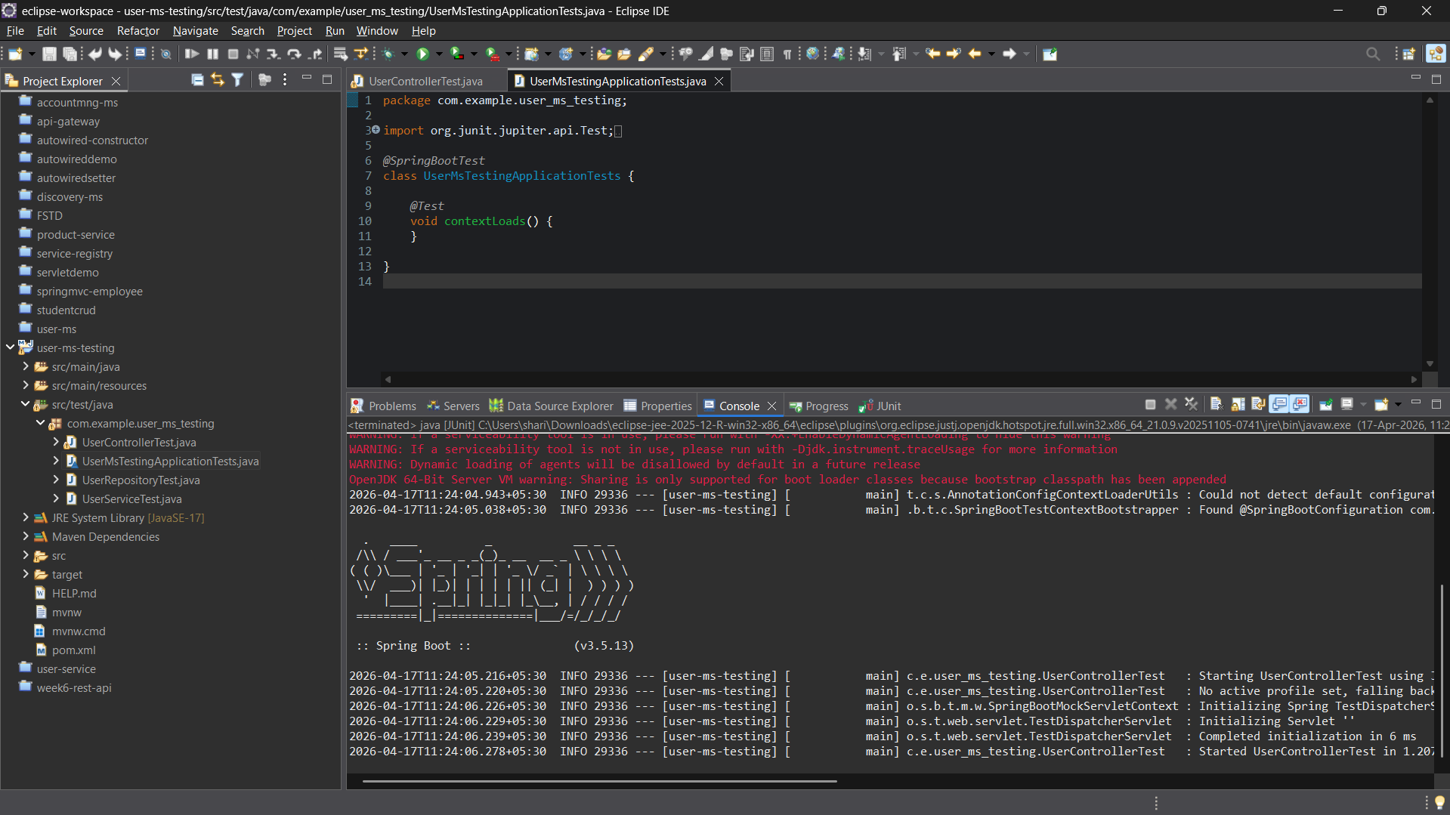

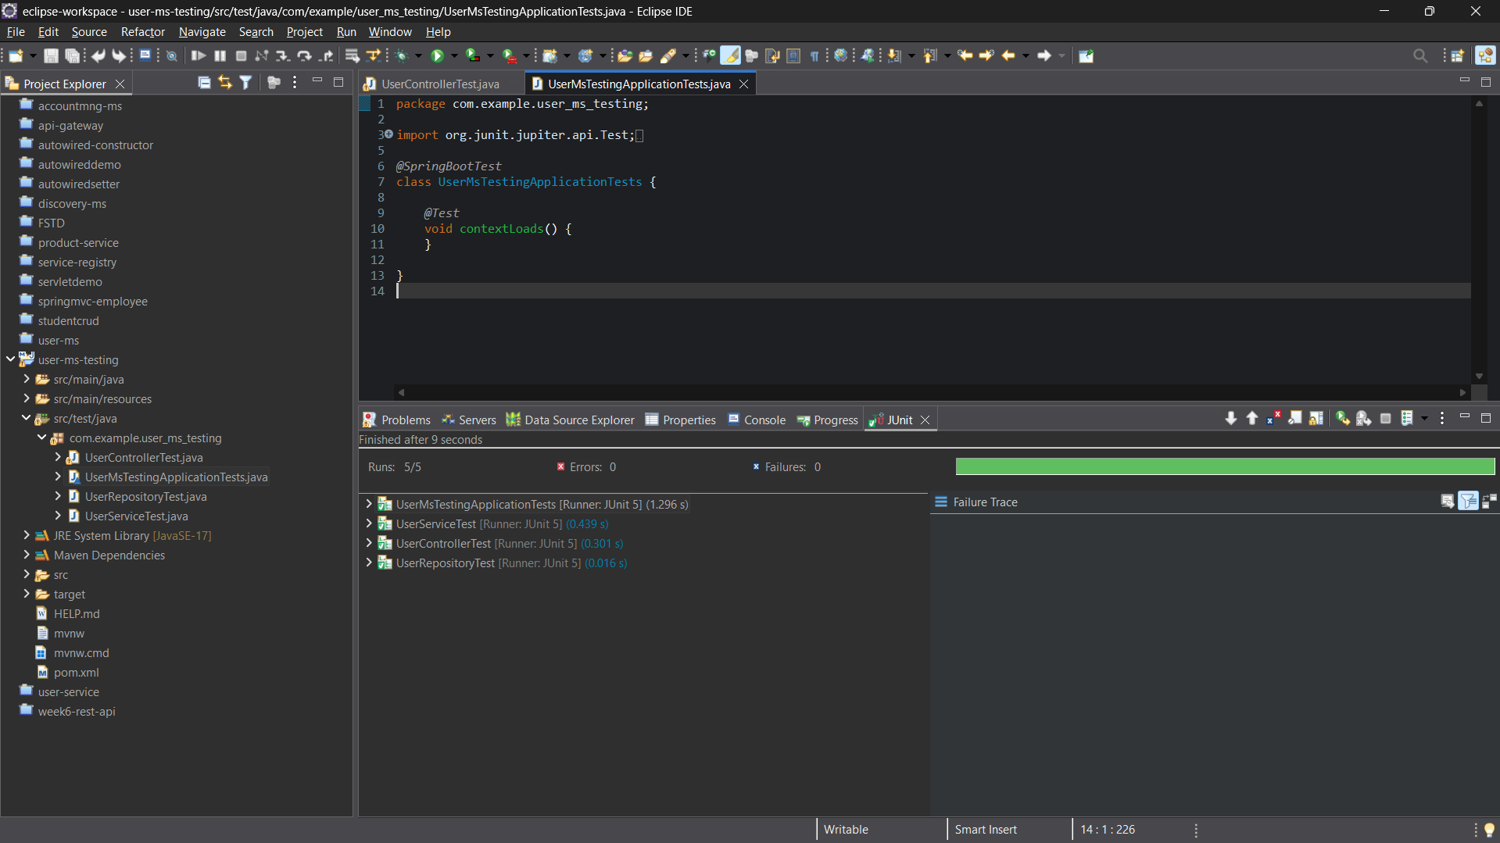

RESULT
The unit testing of the Java microservice was successfully implemented using JUnit 5 and Mockito. Test cases were executed for the service layer, controller layer, and data handling ensuring application independently.

